Mission Statement
To build a clean, intuitive, and powerful trading journal and position management system. that truly understands how options traders think, trade, and remember their ideas.
We aim to replace fragmented spreadsheets with a living model that:
- Captures every trading campaign (from the single vertical spread to multi-month diagonal used to generate premium) as a coherent whole.
- Preserves financial history through immutable transaction events while letting traders reason at the level of strategy, intent, and performance
- Makes recording fast and natural — so entering a debit spread, iron condor, or premium scrape feels like telling the story instead of fighting software
- Provides trustworthy accounting — weighted average cost basis, realized/unrealized P&L, tax continuity, days held, and ROI — calculated automatically and correctly across adjustments, rolls, and assignments
- Grows with the trader — from a personal journal of hundreds of ideas across dozens of symbols to a portfolio-level view of performance, bias, edge, and evolution over years

In short: We exist to give options traders a digital companion that thinks like a trader — remembers the full story of every idea, and handles the math behind it, so the trader can focus on finding, executing, and improving the next edge.

Proposed Design
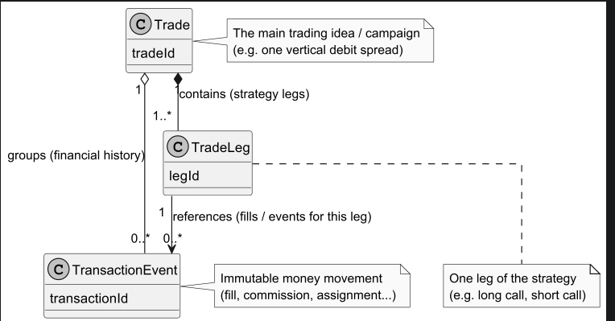
Summary of the Trade Design (as of current iteration)
This design positions Trade as the central, meaningful unit — the trader's coherent "idea" or "campaign" — while keeping accounting and execution details clean and immutable.
Primary Actors:
- Trade
  - Composite Aggregate Root
    - Owns its lifecycle, status, and performance metrics
    - Represents one full trading story
      - (e.g. a vertical debit spread, strangle with rolls, premium scraping campaign)
    - Provides clear mental model alignment:
      - "How did last week’s $PLTR-15 short premium trade go?" is one object, not scattered rows
- TradeLeg
  - Strategy Structure
    - Explicitly models each component of the strategy (e.g. long call leg, short call leg)
    - Supports multi-leg trades naturally (verticals, iron condors, etc.)
    - Allows per-leg details (strike, expiration, direction: LONG/SHORT) without bloating the parent
- TransactionEvent
  - Immutable Financial Truth
    - Prevents accidental mutation of accounting history
    - Captures every money movement as audit-safe, historical facts
      - (fills, commissions, assignments, expirations)
    - Links cleanly to TradeLeg (which fill belongs to which leg?) and Trade (overall campaign history)
- Relationships & Multiplicities
  - 1 Trade → many TradeLegs (contains/strategy)
  - 1 Trade → many TransactionEvents (groups/financial history)
  - 1 TradeLeg → many TransactionEvents (references/fills per leg)

Key Strengths We Like:
- Simple, intuitive, and enforces ownership without deep nesting
- Extensibility Without Clutter
  - Room to add Trade domain attributes without forcing them into core structure
    - Eg: (underlying Instrument, strategyType, quantity, status, notes/thesis)
    - Future-proof for options specifics (Greeks, expiration handling, assignment)
- Mental model matches how you think about trades
- Accounting integrity is preserved
- Easy to query/report at any level (campaign, leg, event)

